BANK LOAN REPORT
SQL Query Document
Data Source: Bank loan Data | Period: 2021
A. SUMMARY — KEY PERFORMANCE INDICATORS
1. Loan Applications
1.a Total Loan Applications
SELECT COUNT(id) AS Total_Application
FROM Bank_loan_Data;
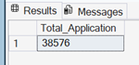

1.b MTD Total Loan Applications
Hard Coded (December 2021):
SELECT COUNT(id) AS MTD_Total_Application
FROM Bank_loan_Data
WHERE MONTH(issue_date) = 12
AND YEAR(issue_date) = 2021;
Soft Coded (Dynamic):
SELECT COUNT(id) AS MTD_Total_Application
FROM Bank_loan_Data
WHERE MONTH(issue_date) = MONTH(GETDATE())
AND YEAR(issue_date) = YEAR(GETDATE());
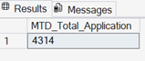

1.c PMTD Total Loan Applications
Hard Coded (November 2021):
SELECT COUNT(id) AS PMTD_Total_Application
FROM Bank_loan_Data
WHERE MONTH(issue_date) = 11
AND YEAR(issue_date) = 2021;

Soft Coded (Dynamic):
SELECT COUNT(id) AS PMTD_Total_Application
FROM Bank_loan_Data
WHERE MONTH(issue_date) = MONTH(DATEADD(MONTH, -1, GETDATE()))
AND YEAR(issue_date) = YEAR(GETDATE());
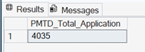

1.d % Increase in Loan Applications (MTD vs PMTD)
Hard Coded:
SELECT ROUND((MTD - PMTD) * 100.0 / PMTD, 2) AS Increase_Percentage
FROM (
SELECT
(SELECT COUNT(id) FROM Bank_loan_Data
WHERE MONTH(issue_date) = 12 AND YEAR(issue_date) = 2021) AS MTD,
(SELECT COUNT(id) FROM Bank_loan_Data
WHERE MONTH(issue_date) = 11 AND YEAR(issue_date) = 2021) AS PMTD
) t;
Soft Coded (Dynamic):
SELECT ROUND((MTD - PMTD) * 100.0 / NULLIF(PMTD, 0), 2) AS Increase_Percentage
FROM (
SELECT
(SELECT COUNT(id) FROM Bank_loan_Data
WHERE MONTH(issue_date) = MONTH(GETDATE())
AND YEAR(issue_date) = YEAR(GETDATE())) AS MTD,
(SELECT COUNT(id) FROM Bank_loan_Data
WHERE MONTH(issue_date) = MONTH(DATEADD(MONTH, -1, GETDATE()))
AND YEAR(issue_date) = YEAR(DATEADD(MONTH, -1, GETDATE()))) AS PMTD
) t;
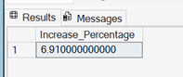

2. Total Funded Amount
2.a Total Funded Amount
SELECT SUM(loan_amount) AS Total_Funded_Amount
FROM Bank_loan_Data;
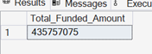

2.b MTD Total Funded Amount
SELECT SUM(loan_amount) AS MTD_Total_Funded_Amount
FROM Bank_loan_Data
WHERE MONTH(issue_date) = 12 AND YEAR(issue_date) = 2021;
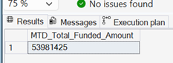

2.c PMTD Total Funded Amount
SELECT SUM(loan_amount) AS PMTD_Total_Funded_Amount
FROM Bank_loan_Data
WHERE MONTH(issue_date) = 11 AND YEAR(issue_date) = 2021;
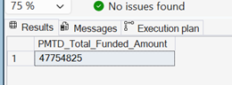

2.d % Increase in Total Funded Amount (MTD vs PMTD)
SELECT ROUND((MTD - PMTD) * 100.0 / NULLIF(PMTD, 0), 2) AS Increase_Percentage
FROM (
SELECT
(SELECT SUM(loan_amount) FROM Bank_loan_Data
WHERE MONTH(issue_date) = 12 AND YEAR(issue_date) = 2021) AS MTD,
(SELECT SUM(loan_amount) FROM Bank_loan_Data
WHERE MONTH(issue_date) = 11 AND YEAR(issue_date) = 2021) AS PMTD
) T;
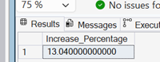

3. Total Amount Received
3.a Total Received Amount
SELECT SUM(total_payment) AS Total_Received_Amount
FROM Bank_loan_Data;
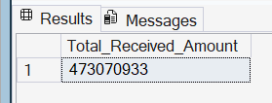

3.b MTD Total Received Amount
SELECT SUM(total_payment) AS MTD_Total_Received_Amount
FROM Bank_loan_Data
WHERE MONTH(issue_date) = 12 AND YEAR(issue_date) = 2021;
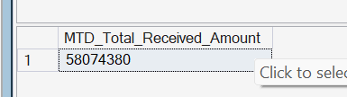

3.c PMTD Total Received Amount
SELECT SUM(total_payment) AS PMTD_Total_Received_Amount
FROM Bank_loan_Data
WHERE MONTH(issue_date) = 11 AND YEAR(issue_date) = 2021;
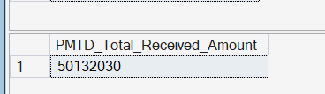

3.d % Increase in Received Amount (MTD vs PMTD)
SELECT ROUND((MTD - PMTD) * 100 / NULLIF(PMTD, 0), 2) AS Increase_Percentage
FROM (
SELECT
(SELECT SUM(total_payment) FROM Bank_loan_Data
WHERE MONTH(issue_date) = 12 AND YEAR(issue_date) = 2021) AS MTD,
(SELECT SUM(total_payment) FROM Bank_loan_Data
WHERE MONTH(issue_date) = 11 AND YEAR(issue_date) = 2021) AS PMTD
) T;
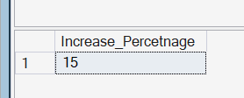

4. Average Interest Rate
4.a Average Interest Rate
SELECT ROUND(AVG(int_rate), 4) * 100 AS Average_Interest_Rate
FROM Bank_loan_Data;
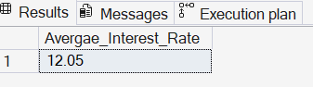

4.b MTD Average Interest Rate
SELECT ROUND(AVG(int_rate), 4) * 100 AS MTD_Average_Interest_Rate
FROM Bank_loan_Data
WHERE MONTH(issue_date) = 12 AND YEAR(issue_date) = 2021;
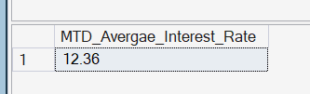

4.c PMTD Average Interest Rate
SELECT ROUND(AVG(int_rate), 4) * 100 AS PMTD_Average_Interest_Rate
FROM Bank_loan_Data
WHERE MONTH(issue_date) = 11 AND YEAR(issue_date) = 2021;
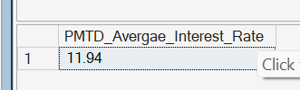

4.d % Increase in Interest Rate (MTD vs PMTD)
SELECT ROUND((MTD - PMTD) * 100 / NULLIF(PMTD, 0), 2) AS Increase_Percentage
FROM (
SELECT
(SELECT ROUND(AVG(int_rate), 2) FROM Bank_loan_Data
WHERE MONTH(issue_date) = 12 AND YEAR(issue_date) = 2021) AS MTD,
(SELECT ROUND(AVG(int_rate), 4) FROM Bank_loan_Data
WHERE MONTH(issue_date) = 11 AND YEAR(issue_date) = 2021) AS PMTD
) T;
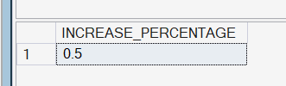

5. Average Debt-to-Income (DTI) Ratio
5.a Average DTI
SELECT ROUND(AVG(dti), 3) AS Average_DTI
FROM Bank_loan_Data;
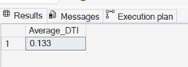

5.b MTD Average DTI
SELECT ROUND(AVG(dti), 3) AS MTD_Average_DTI
FROM Bank_loan_Data
WHERE MONTH(issue_date) = 12 AND YEAR(issue_date) = 2021;
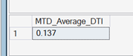

5.c PMTD Average DTI
SELECT ROUND(AVG(dti), 3) AS PMTD_Average_DTI
FROM Bank_loan_Data
WHERE MONTH(issue_date) = 11 AND YEAR(issue_date) = 2021;
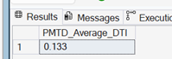

5.d % Increase in DTI (MTD vs PMTD)
SELECT ROUND((MTD - PMTD) * 100 / NULLIF(PMTD, 0), 4) * 100 AS Percentage_Increase
FROM (
SELECT
(SELECT ROUND(AVG(dti), 3) FROM Bank_loan_Data
WHERE MONTH(issue_date) = 12 AND YEAR(issue_date) = 2021) AS MTD,
(SELECT ROUND(AVG(dti), 3) FROM Bank_loan_Data
WHERE MONTH(issue_date) = 11 AND YEAR(issue_date) = 2021) AS PMTD
) T;
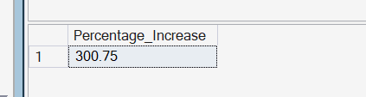

GOOD LOAN ISSUED
1.a Good Loan Percentage
SELECT
COUNT(CASE WHEN loan_status = 'Fully Paid' OR loan_status = 'Current' THEN id END) * 100
/ COUNT(id) AS Good_Loan_Percentage
FROM Bank_loan_Data;
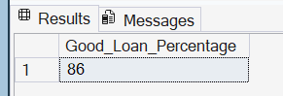

1.b Good Loan Applications
SELECT COUNT(id) AS Good_Loan_Application
FROM Bank_loan_Data
WHERE loan_status = 'Fully Paid' OR loan_status = 'Current';
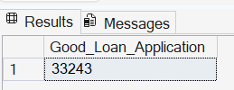

1.c Good Loan Funded Amount
SELECT SUM(loan_amount) AS Good_Loan_Funded_Amount
FROM Bank_loan_Data
WHERE loan_status = 'Fully Paid' OR loan_status = 'Current';
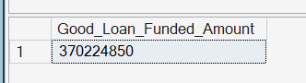

1.d Good Loan Total Received Amount
SELECT SUM(total_payment) AS Good_Loan_Received_Amount
FROM Bank_loan_Data
WHERE loan_status = 'Fully Paid' OR loan_status = 'Current';
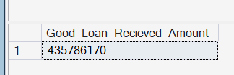

BAD LOAN ISSUED
2.a Bad Loan Percentage
SELECT
COUNT(CASE WHEN loan_status = 'Charged Off' THEN id END) * 100
/ COUNT(id) AS Bad_Loan_Percentage
FROM Bank_loan_Data;
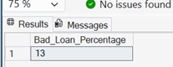

2.b Bad Loan Applications
SELECT COUNT(id) AS Bad_Loan_Application
FROM Bank_loan_Data
WHERE loan_status = 'Charged Off';
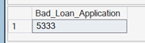

2.c Bad Loan Funded Amount
SELECT SUM(loan_amount) AS Bad_Loan_Funded_Amount
FROM Bank_loan_Data
WHERE loan_status = 'Charged Off';
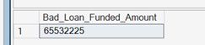

2.d Bad Loan Total Received Payment
SELECT SUM(total_payment) AS Bad_Loan_Received_Amount
FROM Bank_loan_Data
WHERE loan_status = 'Charged Off';
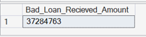

LOAN STATUS SUMMARY
All-Time Loan Status Breakdown
SELECT
loan_status,
COUNT(id) AS Total_Loan_Applications,
SUM(total_payment) AS Total_Amount_Received,
SUM(loan_amount) AS Total_Funded_Amount,
ROUND(AVG(int_rate * 100), 4) AS Interest_Rate,
ROUND(AVG(dti * 100), 4) AS DTI
FROM Bank_loan_Data
GROUP BY loan_status;
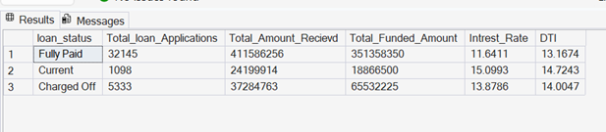

MTD Loan Status Breakdown (December 2021)
SELECT
loan_status,
COUNT(id) AS MTD_Total_Loan_Applications,
SUM(total_payment) AS MTD_Total_Amount_Received,
SUM(loan_amount) AS MTD_Total_Funded_Amount,
ROUND(AVG(int_rate * 100), 4) AS MTD_Interest_Rate,
ROUND(AVG(dti * 100), 4) AS MTD_DTI
FROM Bank_loan_Data
WHERE MONTH(issue_date) = 12 AND YEAR(issue_date) = 2021
GROUP BY loan_status;
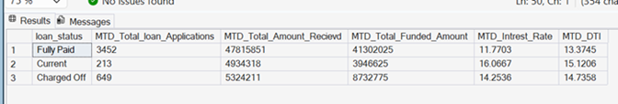

B. BANK LOAN REPORT — OVERVIEW
By Month
SELECT
MONTH(issue_date) AS Month_Number,
DATENAME(MONTH, issue_date) AS Month,
COUNT(id) AS Total_Loan_Applications,
SUM(total_payment) AS Total_Amount_Received,
SUM(loan_amount) AS Total_Funded_Amount
FROM Bank_loan_Data
GROUP BY MONTH(issue_date), DATENAME(MONTH, issue_date)
ORDER BY MONTH(issue_date);
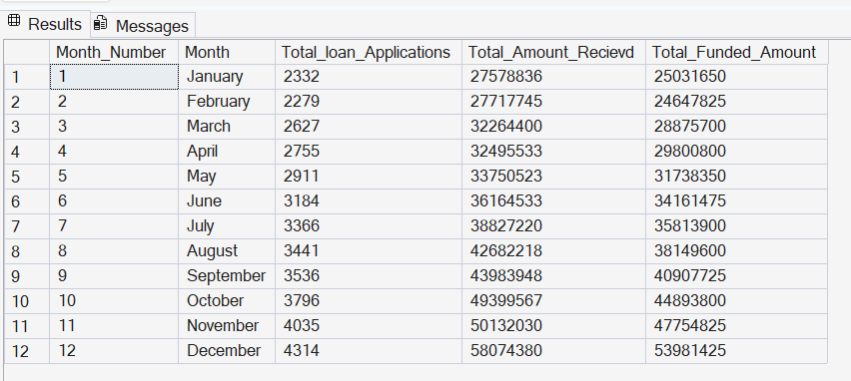

By Purpose
SELECT
purpose,
COUNT(id) AS Total_Loan_Applications,
SUM(total_payment) AS Total_Amount_Received,
SUM(loan_amount) AS Total_Funded_Amount
FROM Bank_loan_Data
GROUP BY purpose ORDER BY purpose;
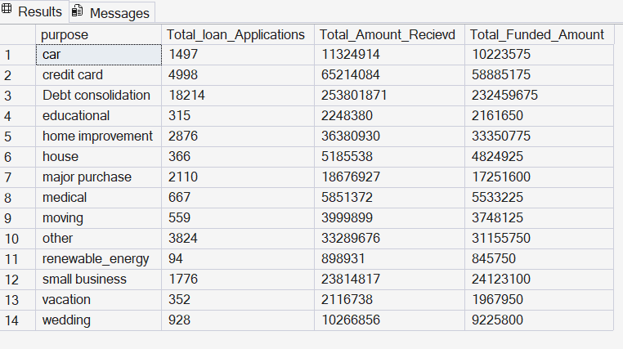
By Home Ownership
SELECT
home_ownership,
COUNT(id) AS Total_Loan_Applications,
SUM(total_payment) AS Total_Amount_Received,
SUM(loan_amount) AS Total_Funded_Amount
FROM Bank_loan_Data
GROUP BY home_ownership
ORDER BY home_ownership;
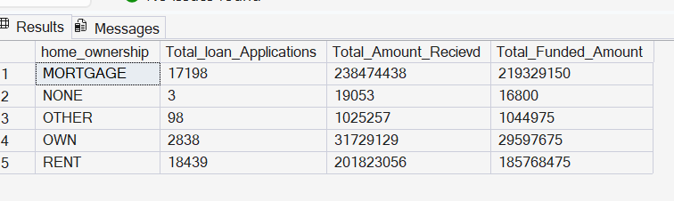

By Employee Length
SELECT
emp_length,
COUNT(id) AS Total_Loan_Applications,
SUM(total_payment) AS Total_Amount_Received,
SUM(loan_amount) AS Total_Funded_Amount
FROM Bank_loan_Data
GROUP BY emp_length
ORDER BY emp_length;
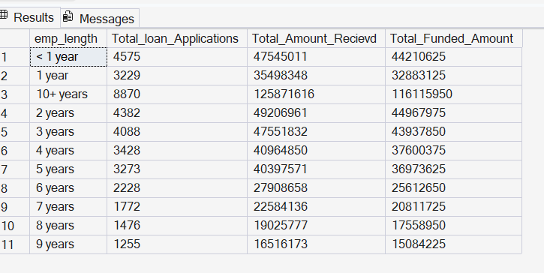

By Term
SELECT
term,
COUNT(id) AS Total_Loan_Applications,
SUM(total_payment) AS Total_Amount_Received,
SUM(loan_amount) AS Total_Funded_Amount
FROM Bank_loan_Data
GROUP BY term
ORDER BY term;
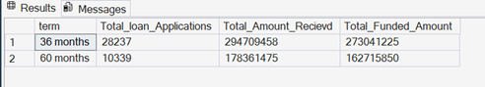

By State
SELECT
address_state,
COUNT(id) AS Total_Loan_Applications,
SUM(total_payment) AS Total_Amount_Received,
SUM(loan_amount) AS Total_Funded_Amount
FROM Bank_loan_Data
GROUP BY address_state
ORDER BY address_state;
